Ninja Product Overview

Contents

1.0. Introduction 3

1.1. Purpose 3

1.2. Scope 3

1.3. Overall Description 3

2.0 Basic Functionality 4

2.1 Home Page 5

2.2 Search Result Page 7

2.3 Landing Page 8

2.4 Product Detail Page 11

2.5 Product Availability Page 13

2.6 Cart Page 14

2.7 Checkout Page 16

2.8 Payment Page 17

2.9 Confirmation Page 18

3.0 Supporting Information 19

Revision History

|  |  |  |  |
| --- | --- | --- | --- |
| **Date** | **Version** | **Description** | **Author** |
| 07/22/2015 | 1.0 | Product Overview | QA Team |
| 07/27/2015 | 1.1 | Product Overview | QA Team |
|  |  |  |  |
|  |  |  |  |

# 1.0. Introduction

## 1.1. Purpose

The purpose of this document is to present a broad overview of the Web based holiday activities booking system. It will explain the purpose and features of the system, the interfaces of the system, what the system will do, the constraints under which it must operate and how the system will react to external stimuli. This document is intended for providing a high level insight of the system.

## 1.2. Scope

## 1.3. Overall Description

Local Tours websites are owned, operated and managed by Isango! Limited. Isango! is a leading specialist retailer of travel experiences including tours and activities, attraction tickets and theatre breaks. Isango! was started in 2007, and has its headquarters in London, UK.

With so many great tours and activities on offer Local Tours websites provides you a dedicated website which breaks down all the available tours and activities into simple-to-understand categories and helps you pick the ones that are right for you.

Local Tours websites uses our years of experience in helping customers plan their perfect trip combined with our excellent network of suppliers to bring you handpicked tours at unbeatable low prices.

Isango is a specialist retailer of tours, experiences and attraction tickets. Through our local tours websites we allow consumers to research and book all their holiday activities online. Isango! Limited manage and operate a range of brands including Love Orlando Tickets, Just London Theatre Breaks and Paris Magic Moments as well as destination specialist sites such as Local Paris Tours. In 2013 Isango! Limited served customers in more than 150 countries.

We, like you, are travelers who have come to expect that the online sites ought to offer much more than telling us what the best price is to get from A to B, or giving us a list of hotels in a particular city. There have got to be sites like that but we think that online travel should move to the next level. We believe we travel to do things, find out about cultures, people, and places and see what the world has to offer. First, to tell you all about a destination - the stuff you need to know to understand a place, and have a complete view of the experiences you can find over there. Then, to bring those products together under one roof for you to plan and book in the most convenient way.

# 2.0 Basic Functionality

This section provide a bird eye view about how web application works. Below mentioned are the basic pages user encounter while interacting with website.

* Home Page.
* Search Result Page.
* Landing Page.
* Product Detail Page.
* Product Availability Page.
* Cart Page.
* Payment Page.
* Confirmation Page.

# 2.1 Home Page

* Application displays home page when user launch local tours website URL.

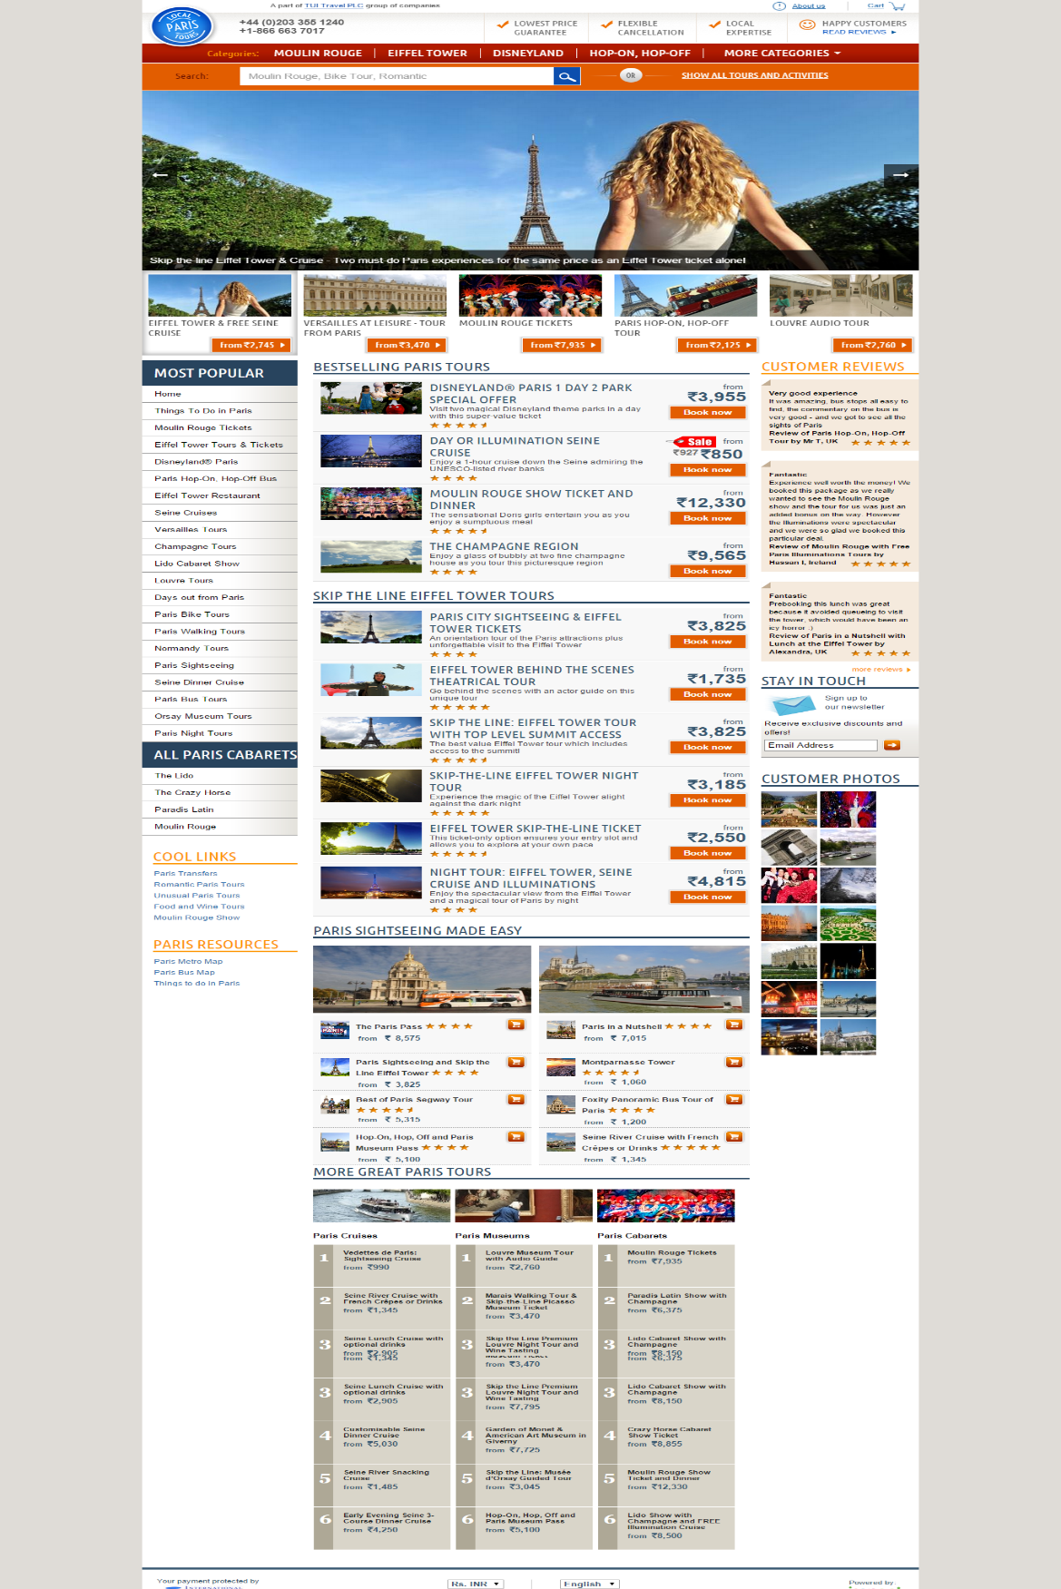

* Home page have following below mentioned sections:

1. Header
2. Search module
3. Hero Merchandise module
4. BESTSELLING PARIS TOURS
5. Customer Reviews
6. Most Popular
7. Cool Links
8. MORE GREAT TOURS
9. Footer

* Application allows user to perform search using destination or activity’s name.
* Application has feature of ip-2-location which enables website to display currency of region from where it is launched.
* Application allows user to change product price currency. Below mentioned are the available current on website:

1. AUD
2. CAD
3. EUR
4. GBP
5. HKD
6. INR
7. SGD
8. USD



* Application allows user to change currency from dropdown and all price display in same currency throughout current session.

# 2.2 Search Result Page

* Application display search result page when user perform search from search text box display on home page.
* Application allow user to select any product display as search result.
* Application displays search result page when user click on link “Show all tours and activities” display on home page.
* Application allows user to change product price currency. Below mentioned are the available current on website:

1. AUD
2. CAD
3. EUR
4. GBP
5. HKD
6. INR
7. SGD
8. USD

* Application allows user to change currency from dropdown and all price display in same currency throughout current session.
* Product display in search results with below mentioned information:

1. Product Image.
2. Book Now Button
3. Product Price
4. Product Rating

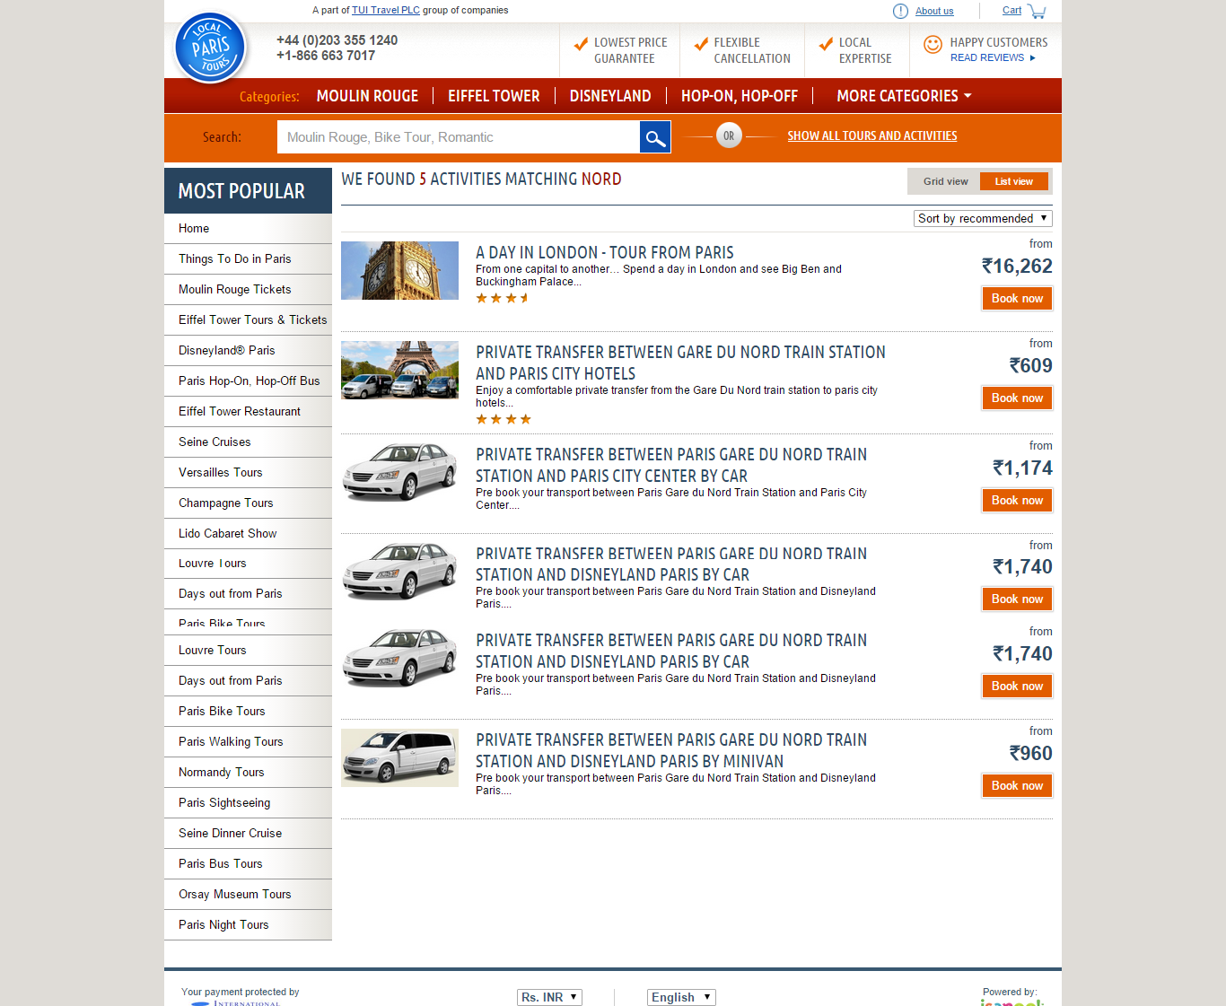

# 2.3 Landing Page

* Application displays landing page when user click on any available categories on home page.
* Application also display landing page when user perform search and select search term from suggestions.
* Application displays categories specific page when user click on any Categories link display below header. Below mentioned are the areas display on the page:

1. Header
2. Categories
3. Search Area
4. Hero Image
5. Social Icons
6. Description
7. Left Link module
8. Customer Reviews
9. Customer Photos
10. Your payment protected image
11. Currency dropdown
12. Language dropdown
13. About Us
14. Customer Care
15. Terms & Conditions
16. Isango Logo.
17. Social Media Icons.

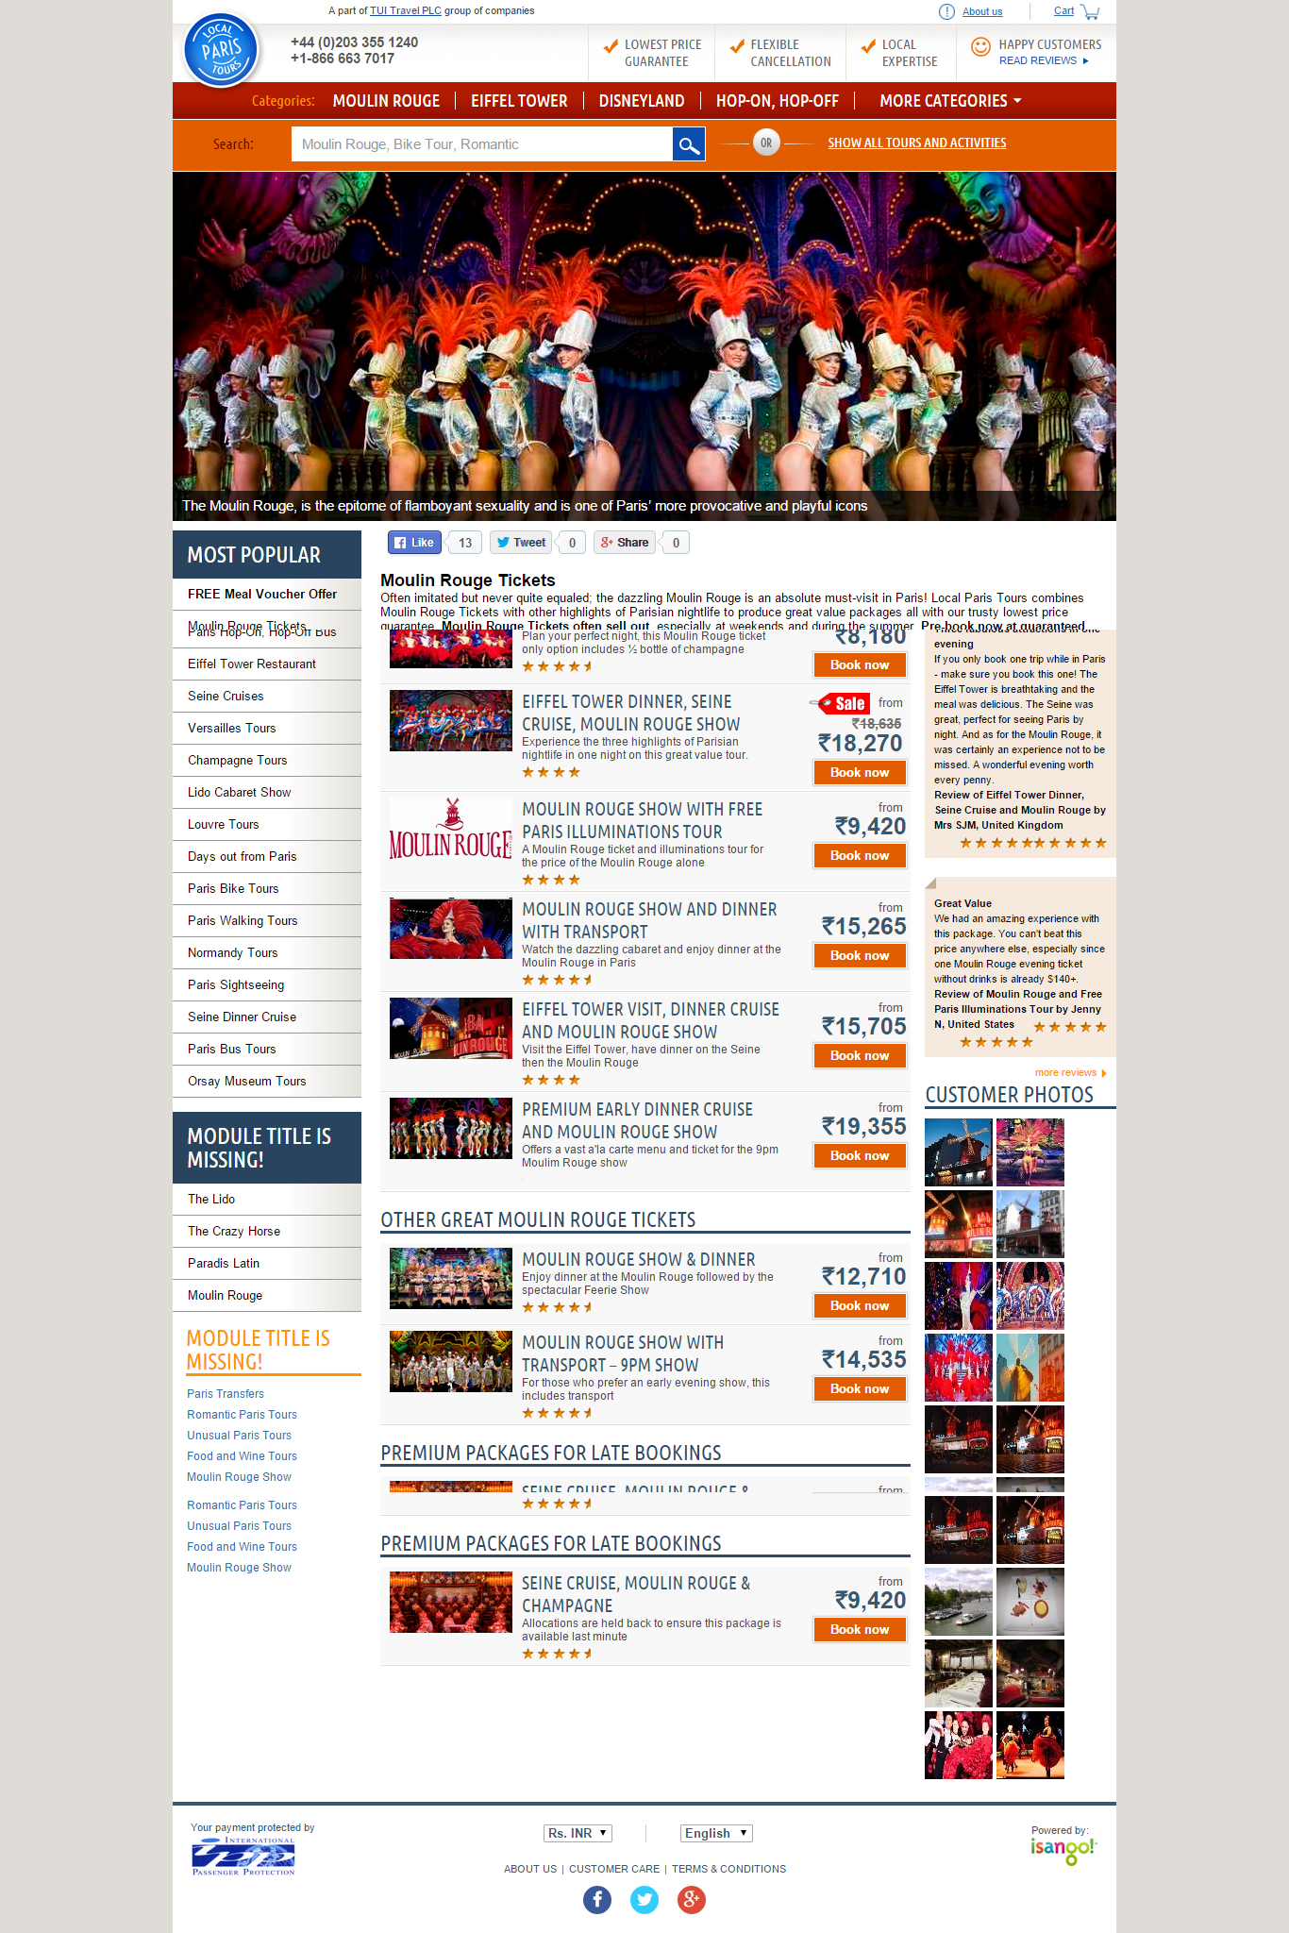

# 2.4 Product Detail Page

* Application displays product detail page when user click on any product display in search result or products display on home page.
* Application display below mentioned items on product detail page:

1. Social Icons
2. Product Images.
3. Availability module.
4. Customer reviews
5. Inclusions and Exclusions
6. Cross sell module.
7. Language and currency dropdown

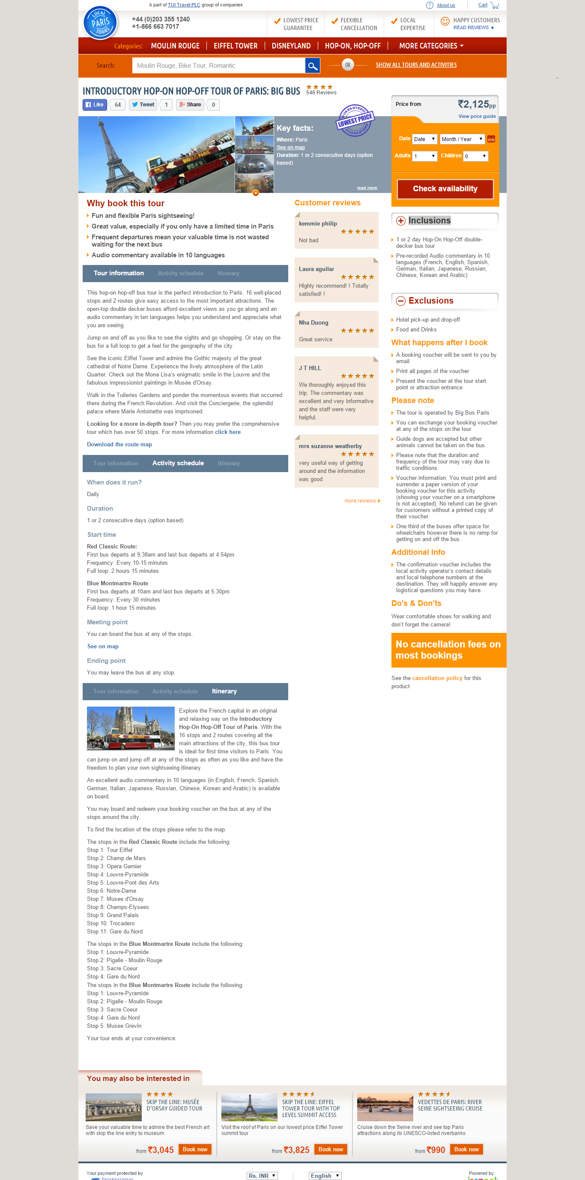

* If one product added in cart application displays multi save icon with availability module on product detail page.

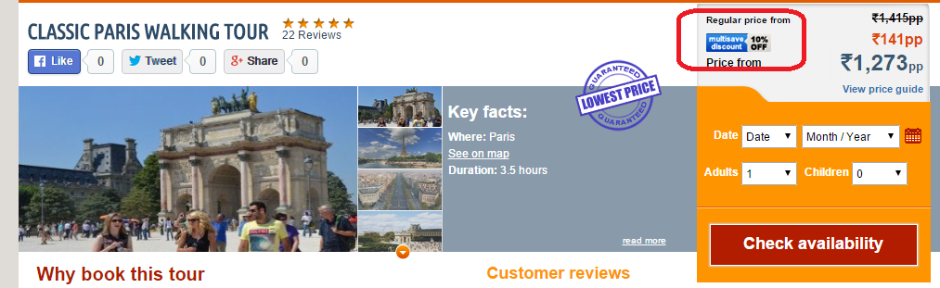

* Application display child policy along with availability module.

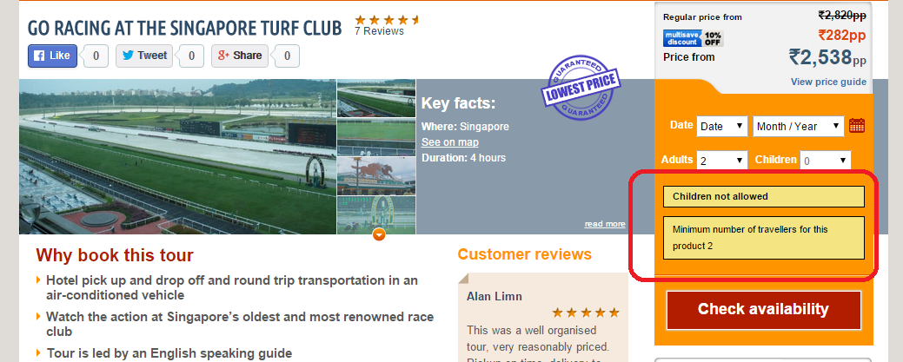

# 2.5 Product Availability Page

* Application displays Availability page when user enter information in Availability module display on product detail page and click on check Availability button.
* Application displays all the options available for product on selected date.
* Application allow user to select options and user can add product in cart.

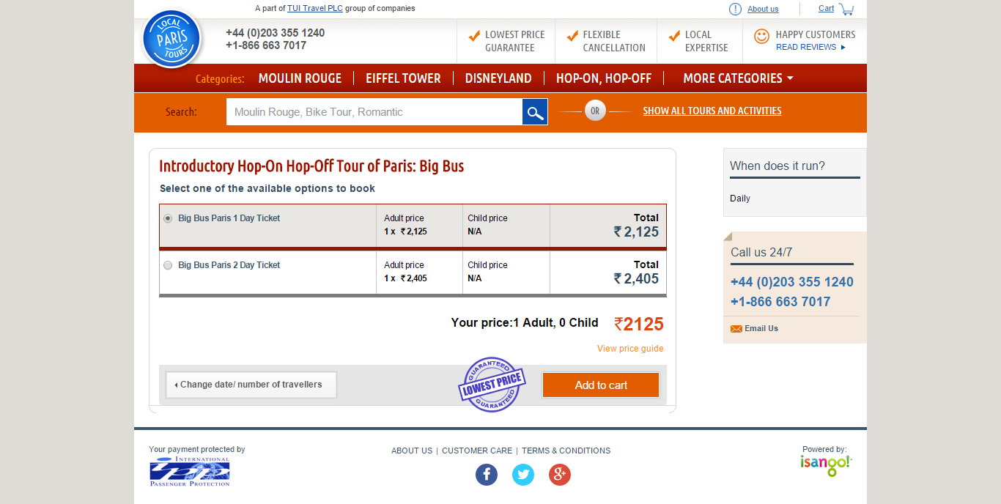

# 2.6 Cart Page

* Application displays cart page when user add product from product detail page in case of availability user select option and add to cart.
* Application display below mentioned items and sections on cart page.

1. Added product by user
2. Product name
3. Product cost
4. Total cart cost
5. Per Product number of travelers
6. Change date/ number of travelers button
7. voucher/discount code
8. Continue shopping Button
9. Secure Checkout
10. Cross Sell module

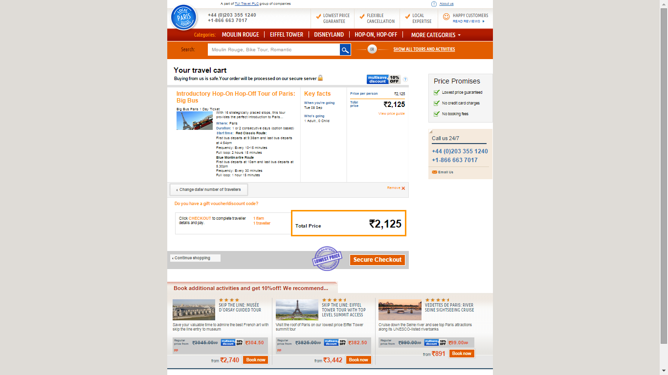

* Application displays multi save option on cart page. As per multi save option if user add first product now user enable for discount on next products to be added in same cart.
* Application display multi save icons with cross sell module and also with product added in cart.

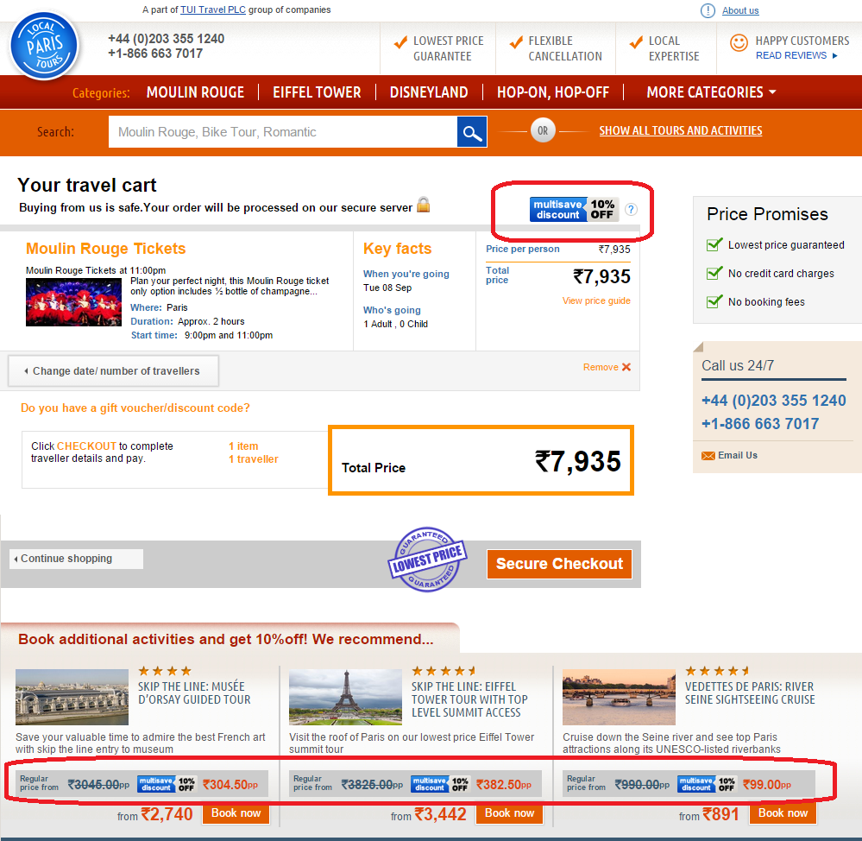

# 2.7 Checkout Page

* Application displays checkout page when user click on secure checkout on cart page.
* Application displays below mentioned items on page:

1. Lead Traveller Name
2. First name
3. Last Name
4. Meeting point
5. Special request

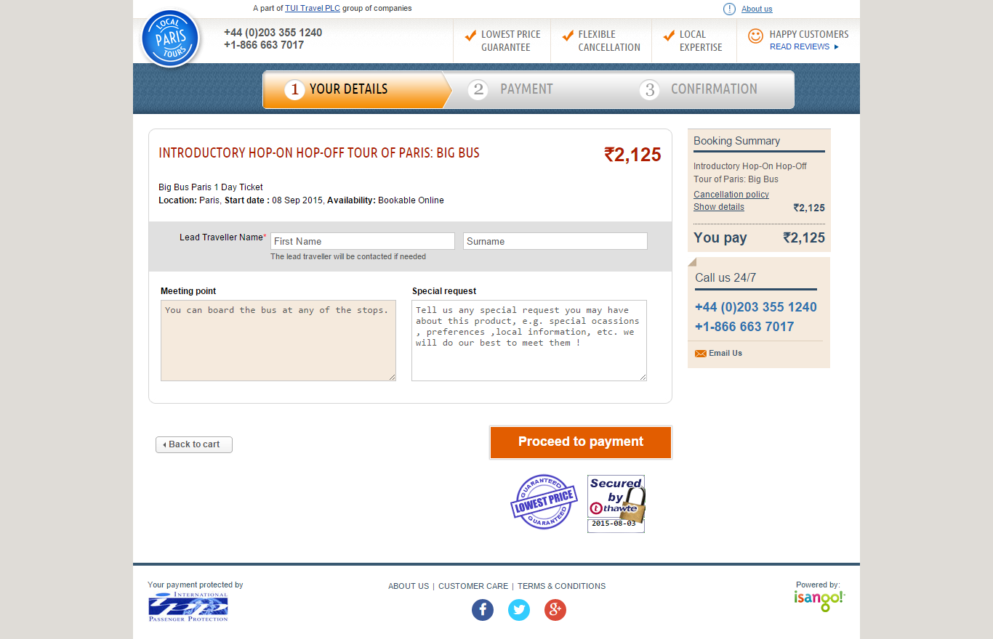

# 2.8 Payment Page

* Application displays payment page when user click on proceed to payment on cart page on checkout page.
* Application displays below mentioned fields on page.

1. Contact Information
2. Email address
3. Confirm email address
4. Phone
5. Secure Credit Card Payment
6. Card type
7. Card Number
8. Cardholder name
9. Expiry date
10. Security code
11. Billing Address
12. Address (Line1)
13. Address (Line 2)
14. City
15. Country/State
16. Post code/ Zip code
17. Country
18. Terms & Conditions
19. Term and conditions checkbox
20. Confirm and Pay button

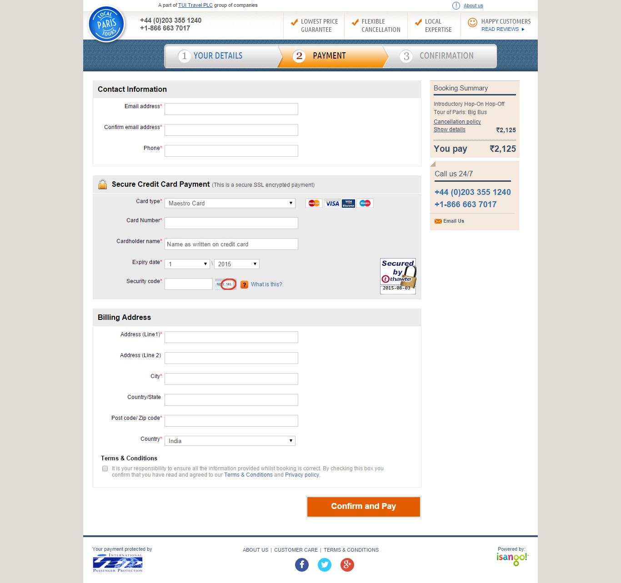

# 2.9 Confirmation Page

* Application displays confirmation page when user click on confirm and pay on payment page on checkout page.
* Application displays confirmation page. Below mentioned information display :

1. Booking reference number.

2. Payment summary

3. Product name and price

4. Total booking amount

5. Booking voucher available to print immediately

6. Call us 24/7

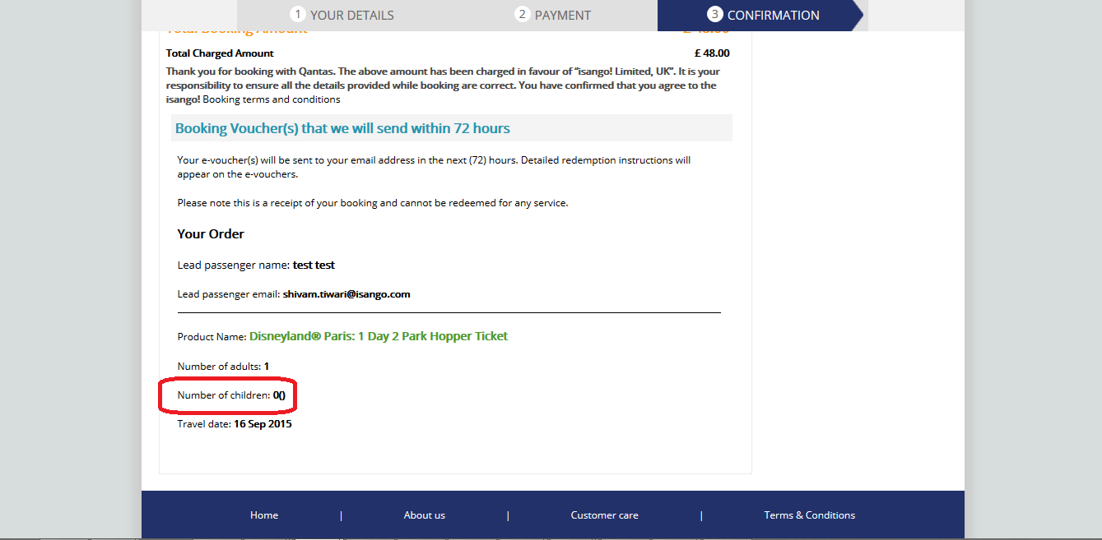

# 3.0 Supporting Information

Please refer the following document for more detailed information:

1. Smoke Test Cases
2. Regression Test Cases